# NPRO

## Save Selection Click – NPOP Screen:

Question 1: The Save selection is only for recipient details table, not the whole edit screen? The docket number, FIPS code, OTHP id, event date and receipt number are only for document generation?  
  
**Response**: Yes, the "Save Selection" is only for the **Recipient Section** (Address, Print Method, and Delivery Method). The error messages **"Invalid FIPS Code," "Invalid OTHP ID,"** and **"Invalid Date"** will appear when you click the **Preview Document** button.   
  
POPUP UI – NPOP Screen:

**Question 2:** No UI for cancellation and return to NPRO screen confirmation Popup. Save selection confirmation popup for modifying the recipient details.

**Response:** Document updated for Save, cancel and Clear button. Please check Scenario **8** ,**9** and **10**

## Receipt Number – NPOP Screen:

**Question 3:** How to find out which forms are required, and which are not?

**Response: Below are BA Comments regarding Receipt Number.  
“Receipt Number field is not used for any functionality”**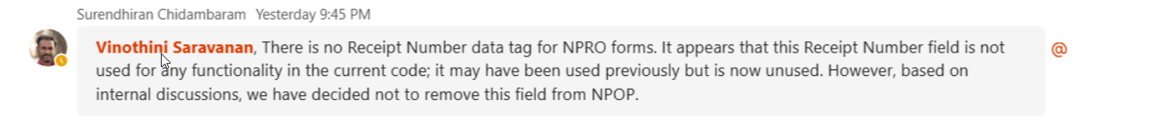

## Blank Document – NPOP Screen:

4.5 - Blank Document & Open Preview: cannot understand the blank document preview in updated document.

## Service Names:

What is the purpose of service names?

## Recipient Grid – NPOP Screen:

What are the options for address's state in recipient grid's accordion?

**Response :**

1. NJKiDS document generation system follows an address hierarchy to select an appropriate address for mailing the document. The address displayed is the most recent, non-end dated, verified address in its category. If there are no confirmed good, non-end dated addresses in the category, then the system will apply the rules of the address hierarchy to determine the address to display.
2. The system displays the Mailing, Primary Residential, and Secondary Residential address for each default recipient who is a case member.
3. For other recipients such as employers, attorneys, or other parties, the available address from the OTHP table will be displayed.